WINTER YOUTH RETREAT 2018
Friday March 2- Saturday March 3
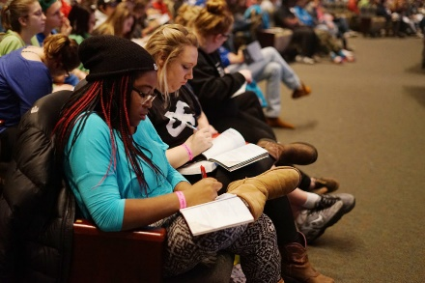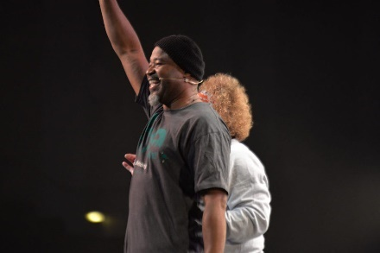

ABOUT PLANETWISDOM
PlanetWisdom is a two-day, regional discipleship conference designed to challenge middle and high school students to dig deeper into the Bible and see their world from God’s perspective.
Your students will hear teaching they can relate to. They’ll have opportunities to reflect and engage—as a group and independently—using their own PlanetWisdom journals to guide them more fully into the Bible.
SPEAKERS & ARTISTS
At PlanetWisdom, you’ll come for the fun—and keep coming back for the life-changing discipleship experiences. Check out our amazing 2017 lineup. They’ll get you on your feet with worship, laughter and praise.
The Skit Guys Fred Lynch Heather Flies
TOTAL PRICE: Conference, Room & Food…..$100
Space is very limited….reserve your spot now!!!
****************************************************
Planetwisdom Youth Conference – March 2-3
Youth Name:____________________________________
Email:__________________________________________

PLANET WISDOM SCHEDULE
Friday
- 5:30pm Check-In and Lobby Opens**
- 6:30pm Auditorium Doors Open
- 7:00pm Youth Leader Gathering
- 7:30pm Session 1
- 9:00pm Session 2
- 10:30pm Friday Night Ends
Saturday
- 8:30am Doors Open
- 9:00am Session 3
- 10:45am Session 4
- 12:30pm Lunch
- 1:55pm Youth Leader Gathering
- 2:00pm Session 5
- 3:30pm Session 6
- 4:30pm PlanetWisdom Ends

**Please note – we will probably be leaving around 1:00pm on Friday which requires your child to leave school early. If need be, I can write them a note explaining they are leaving for religious reasons.

ACCOMODATIONS

Fairfield Inn
2610 Prince William Pkwy
Woodbridge, VA 22192

conference site

HYLTON MEMORIAL CHAPEL
14640 Potomac Mills Rd
Woodbridge, VA 22192

