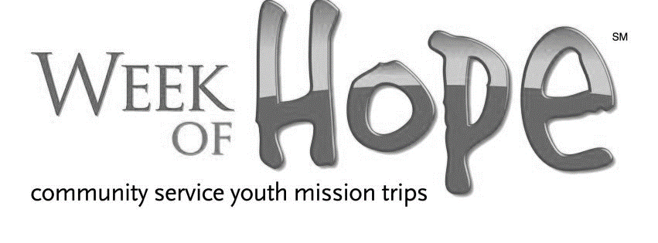

Camper First Name______________________ Last Name_______________________
Address ____________________________________________________________________
Email:_________________________________ Cell________________________________
Grade entering in the fall of 2019_________________
How many WOH camps have you attended in the past.____________________

Note: any of the following that have a ‘Yes’ answer require an explanation.
Sexual misconduct of any kind involving children, youth, or adults, including crimes resulting in a conviction?
Yes
No
Violence against another person resulting in a felony conviction within the last 10 years?
Yes
No
Use, or distribution, of illicit drugs or controlled substances resulting in a conviction in the last 10 years?
Yes
No
Property crime resulting in a conviction in the last 10 years?
Yes
No
Any other characteristics which would render person a threat to others?
Yes
No

Parent First Name_________________________________ Last Name_____________________________
Email:________________________________________________
Primary Phone_____________________________ Cell Phone__________________________________
My child and I have seen, read, and agree to every aspect of the Liability and Release Agreement and the Code of Conduct . By signing this form, I hereby authorize Group Mission Trips to use or disclose my child’s protected health information for the purposes of treatment, payment, health care operations, or any other disclosures as allowed by law in connection with any accident, medical incident, or claim made. (Please note: as a participant, you are responsible for your own health insurance needs and are advised to bring your personal health insurance information with you on your mission trip.)
I understand by typing my full legal name below that I am authorizing my digital signature as my legally binding signature.

Camper Signature_______________________________________
Parent Signature_________________________________________ Date_______________________

