Want to do something that makes a difference in someone’s life and in yours?

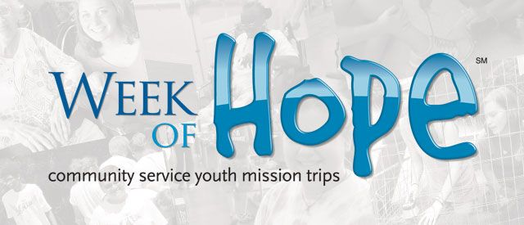
What better way to spend a week of your summer –
We are looking for team members to enter the lives of others and build relationships with the people of Pittsburgh, Pennsylvania in hopes that they’ll experience God while working with them at their work sites.

Week of Hope changes lives- including yours…. we serve in a variety of ways
- Serve at the Boys and Girls Club Kids Camp. You will assist with many activities, including sports, crafts and games.
- Assist a housing organization by processing and organizing newly donated furniture, appliances and other goods in order to help families shop.
- Help in the food pantry, packing bags, stocking shelves, doing food distribution, cleaning, and helping to serve some of the many people in the heart of a tough area.
- Assist church volunteer staff move, remodel and re-launch a food bank and clothing ministry.
- Work with an international humanitarian organization be assisting the Staff in packaging and shipping materials and organizing their distribution area.
Young people make new friends, create new memories and have a wonderful time together. Most importantly, your son/daughter will discover that as they focus on the needs of others… they grow closer to Jesus.
Date: Sunday July 28 ~ Friday August 2, 2019
Cost: $350 for transportation, meals, camp t-shirt & lodging
(Cost may go down with great fundraising throughout the year)
***If for any reason you need financial assistance to make this trip possible for your child please speak with Joanne- we will NEVER let a youth not participate in an event due to financial hardship. We will surely respect your privacy in this matter – all matters are kept confidential.
Spots are limited so reserve your seat now!
Please fill out the form below and return it to Joanne with deposit- ASAP

Email:_________________________________________ T-shirt Size:____________
Cell #:_________________________ # of years on a Mission Trip:__________
First Payment Due- January 27th

Pittsburg, PA
Mission Trip
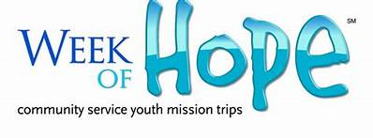

Payment Plan
- January 27th: Payment #1 $125
- March 10th: Payment #2 $125
- April 28th: Payment #3 $100
Total: $350

*Mandatory Training Meetings:
March 24th ~ 5:30-6:30 PM
April 7th~6:00-7:00 PM
May 19th ~5:30-7:00 PM (Pizza dinner included)
June 2^{n d}~7:30-8:30PM
*If you cannot make a training meeting and have a really good excuse then we will find a
make-up time for you!

