The First Presbyterian Church
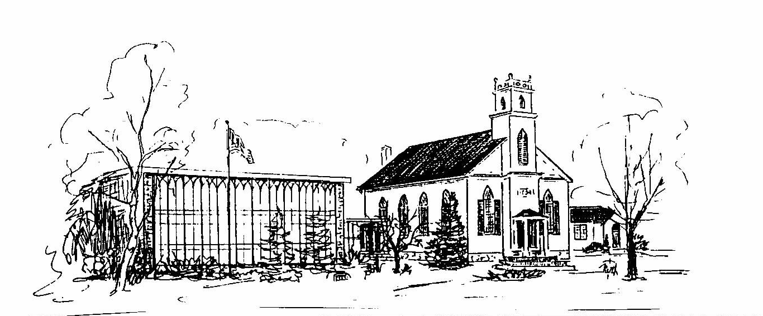

Whippany, New Jersey
Medical Release Form-Adult

Name _____________________________________________ DOB ___________________
Address:__________________________________________________________________________________________________________________________________________
Email _______________________________ Cell Phone _________________________
Emergency Contact
Name__________________________________ Cell#__________________________
Relationship __________________________

LIABILITY RELEASE: In consideration of The First Presbyterian Church of Whippany (FPCW) allowing the Participant to participate in mission team/youth ministry (Activities, Events, Retreats, Lock-Ins, Trips) I, the undersigned, do hereby release, forever discharge and agree to hold harmless Whippany Presbyterian, its pastors, directors, employees, volunteers and teachers (collectively herein the “Church”) from any and all liability, claims or demands for accidental personal injury, sickness or death, as well as property damage and expenses, of any nature whatsoever which may be incurred by the undersigned and the Participant while involved in the mission team/youth activities. I, the Participant, hereby would like to participate fully in mission team/youth ministry activities, including trips away from the church premises. Furthermore, hereby assume all risk of accidental personal injury, sickness, death, damage and expense as a result of participation in recreation and work activities involved therein. I further hereby agree to hold harmless and indemnify said Church for any liability sustained by said Church as the result of the negligent, willful or intentional acts, including expenses incurred.

MEDICAL TREATMENT PERMISSION: I authorize an adult, who is traveling with said group, to consent to any emergency x-ray examination, anesthetic, medical, surgical or dental diagnosis or treatment and hospital care, to be rendered to the minor under the general or special supervision and on the advice of any physician, dentist or medical staff of a licensed hospital or emergency care facility. The undersigned shall be liable and agrees to pay all costs and expenses incurred in connection with such medical and dental services rendered to the child or youth pursuant to this authorization.

EARLY RETURN HOME POLICY: Should it be necessary for said participant to return home due to medical reasons, disciplinary action or otherwise, the undersigned shall assume all transportation costs and responsibility.

TRANSPORTATION PERMISSION: I also hereby give permission to ride in any vehicle driven by an approved and licensed ADULT while attending and participating in activities sponsored by Whippany Presbyterian.

x_______________________________________ x______________________________ ___________
Name of adult participant Signature of adult participant Date

MEDICAL INFORMATION
MEDICAL INFORMATION (Please Print)
Full Name __________________________________________________________
PRIMARY CARE PHYSICIAN
Name:_________________________________________________________________________Phone_______________________________________Date of Tetanus shot _____________
INSURANCE INFORMATION
Medical Insurance Company: _____________________________________
Phone: ____________________________________
Policy/Group ID#: _______________________________________________
Policy Holder’s Name (please print):
_________________________________________________
**Required: Attach a copy of medical insurance card (front & back please)

MEDICAL CONDITIONS: Please answer in detail if applicable or write N/A. Attach additional pages if necessary.
- List any medical conditions you have (asthma, diabetes, epilepsy, etc.):

- List any allergies (drug/medicine, food, and/or environmental) and the severity and type of reaction:

- Please explain any other pertinent information about the participant (i.e. physical, behavioral, or emotional) that would be important for the leaders
to know.

FPCW Photo Release Form
I agree that Whippany Presbyterian may photograph and record my likeness and activities (Images) during church-related activities. I grant the following rights to Whippany Presbyterian: permission to use and re-use, publish and re-publish the image(s) taken during the shoot. Use of the Images for editorial, commercial, advertising, and any other purpose may be done in any medium now existing or subsequently developed, on the church website and on the Internet, and worldwide in perpetuity for the purposes stated above. No name will ever be associated with your picture unless specific permission is granted by you.

______________________________________________ __________________
Signature Date

Adult Covenant of Community Expectations
The following rules and guidelines are equally binding on adult leaders/chaperones and youth.
Non-Negotiable Rules
• No use of illicit drugs or alcohol
• Presence at and full participation in all group activities, including adherence to curfews and other time-related instructions
• Smoking and the use of tobacco products are only allowed in designated areas.

______________________________________________ __________________
Signature Date

Image means all photographs, film, or other recordings taken of you as part of the Shoot.

