Friday May 31st 5:00PM -8:30PM
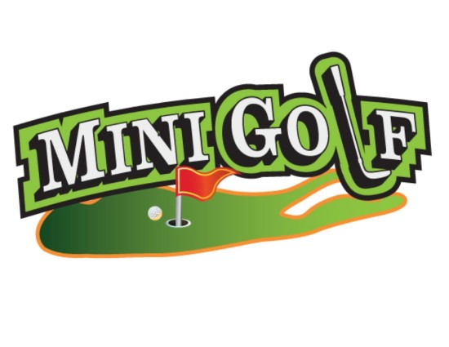

All proceeds go to benefit our two summer mission trips~
High School mission team heading to Mountain T.O.P. Tennessee
Service mission team going to Pittsburg, Pennsylvania with Group Mission Trips
Sponsorship: Hole sponsorship: $25 or a 10” x 10” sign $40 for a 24” x 16” sign.
Course sponsorship $100-you may provide banners or
other signage/materials to be displayed at beginning of the course.
All sponsors may distribute materials at our “sponsor table”.
Please complete the form below and drop off to Joanne Willans at FPCW or mail it to First Presbyterian Church of Whippany c/o Mini Golf 494 Route 10, Whippany, NJ 07981
Deadline is May 25th
Questions, please contact Joanne at youthfpcwhippany@gmail.com
or through our website: youthfpcwhippany.org
Mini Golf Sponsorship
Name:_________________________________
Business:_____________________________________________________
Sponsor: _____Hole ($25) _____Hole ($40) _____Course ($100)
Checks made payable to: First Presbyterian Church of Whippany

